**QSMART –HEAT EXCHANGER AND FAN REPLACEMENT**

**PROCEDURE**

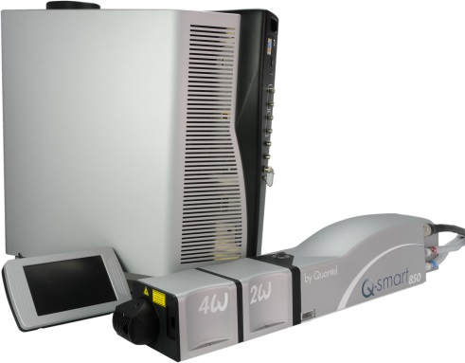

**Toolkit:**

Allen keys

**System** : QSMART

|  |  |
| --- | --- |
| 3/E03/0022A | **Q-SMART CG HEAT EXCHANGER** |
| 4/VEN/0046 | **Q-SMART CG FAN** |

**Purpose**: This document details how to change fans and heat exchanger

|  |  |  |
| --- | --- | --- |
| Revision | date | modification |
| Initial issue | July 4, 2014 |  |
|  |  |  |
|  |  |  |
|  |  |  |

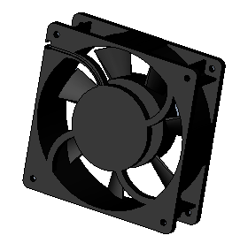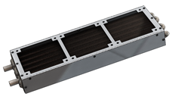

# DISASSEMBLY

* Open the ICE and the cooling group

*See procedure "CG - SM010355-cooling unit"*

# IMPLEMENTATION of the CG FAN

Keep all screws and washers:

|  |  |  |
| --- | --- | --- |
| 12.00 | V/CHC-M0412A2 | CHC M4-12 STAINLESS STEEL A2 |
| 12.00 | R/MU--D04--A2 | MU4 WASHER |

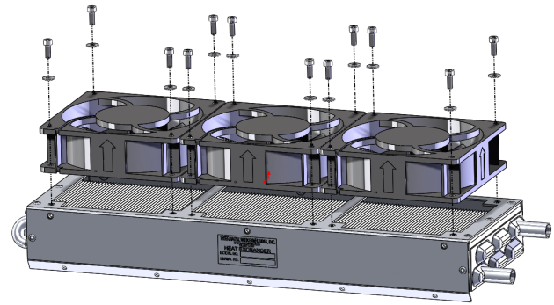

Wires output

Air flow direction

**Tube mounting instructions :**

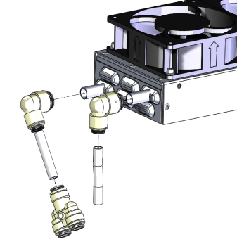

Lower tube

Upper tube

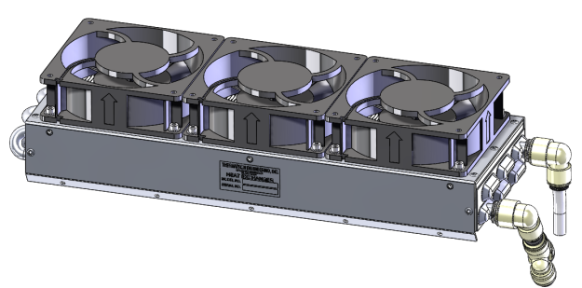

Fan wires to be placed here. Cut wires 40 mm outside heat exchanger. Remove insulation over 8mm

40mm

* Put together all wires with same colour. Insert in one connecting port. One port for one colour (blues with pink)

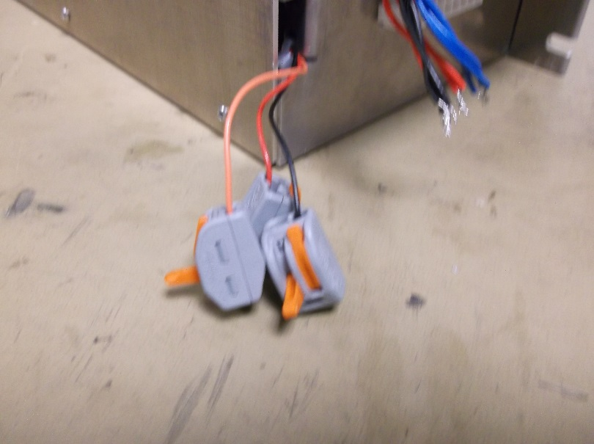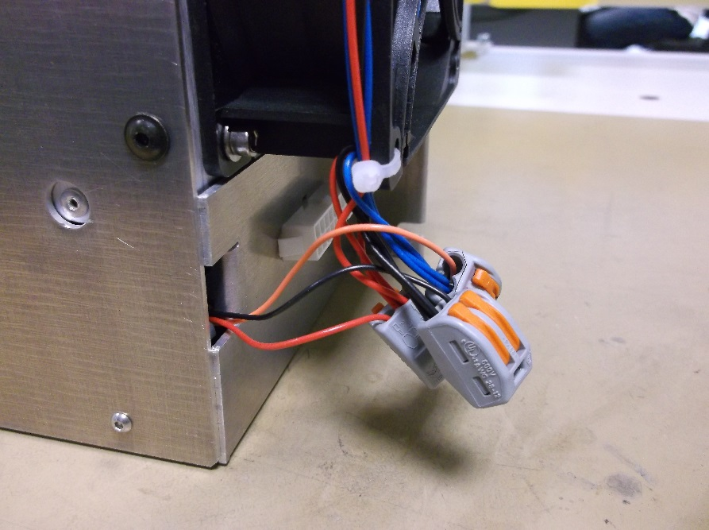

# Heat Exchanger

|  |  |  |
| --- | --- | --- |
| 3.00 | 3/E13/0600 | BHC M4 BLACK SCREW |

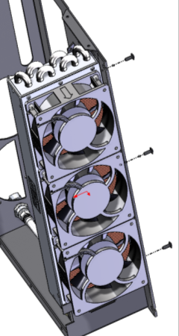

# WIRING

* Connect the cables that have been disconnected

*Refer to "CG-Wiring"*

# TEST AND CLOSING

* Perform the test of CG and close.
* Close the ICE

*Refer to «CG-Test and closing" and "CG - SM010355-cooling group"*